“Planet Earth Needs Our Help”

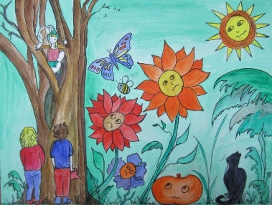
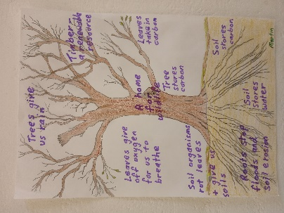
Earth Day 22:
“Action Speaks Louder”

Celebrating the Queen’s Platinum Jubilee
https://queensgreencanopy.org/

“Turning over a new leaf”
– caring for ourselves, our planet and its inhabitants

A celebration of trees, our natural environment and lifestyle changes
(Inspired by the Queen’s Jubilee Green Canopy Project.)

Create and submit an image or story inspired by trees and your natural environment, with helpful lifestyle changes you will make in 2022 and beyond, to turn over a new leaf…

Local artist Marylyn Cropley*, invites you to join her in making lifestyle changes and new habits that bring a sense of well-being and hope for the future. You can create and showcase your fun, informative and lively artwork, share inspirations and actions you will take to help care for ourselves, others and our planet.
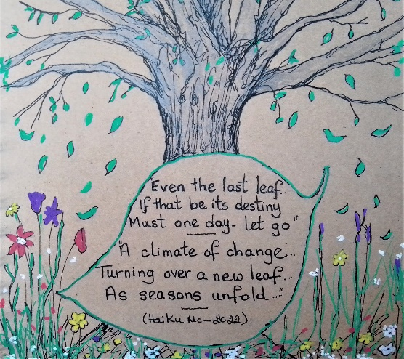
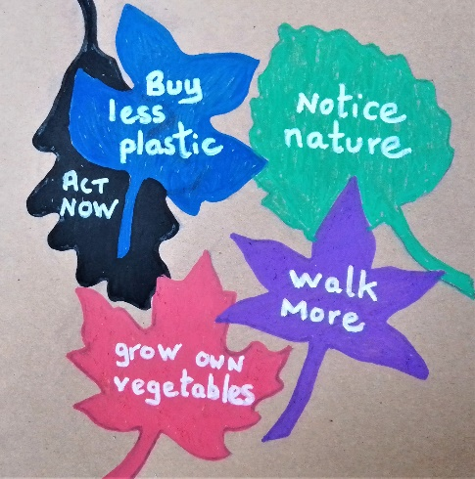

“Turning over a new leaf”: for more information and to submit artwork please go to website: www.planetearthneedsourhelp.com or Email: info@planetearthneedsourhelp.com

*Author of the children’s book “Planet Earth Needs Our Help”

